Healthcare Data Integration and Analysis - Submission

Task 1: Import the data sets from text files into spreadsheet format
Task | Activity | Screenshot of Code and Output
1a | Screenshot of Pharmacy_Claims.xlsx | 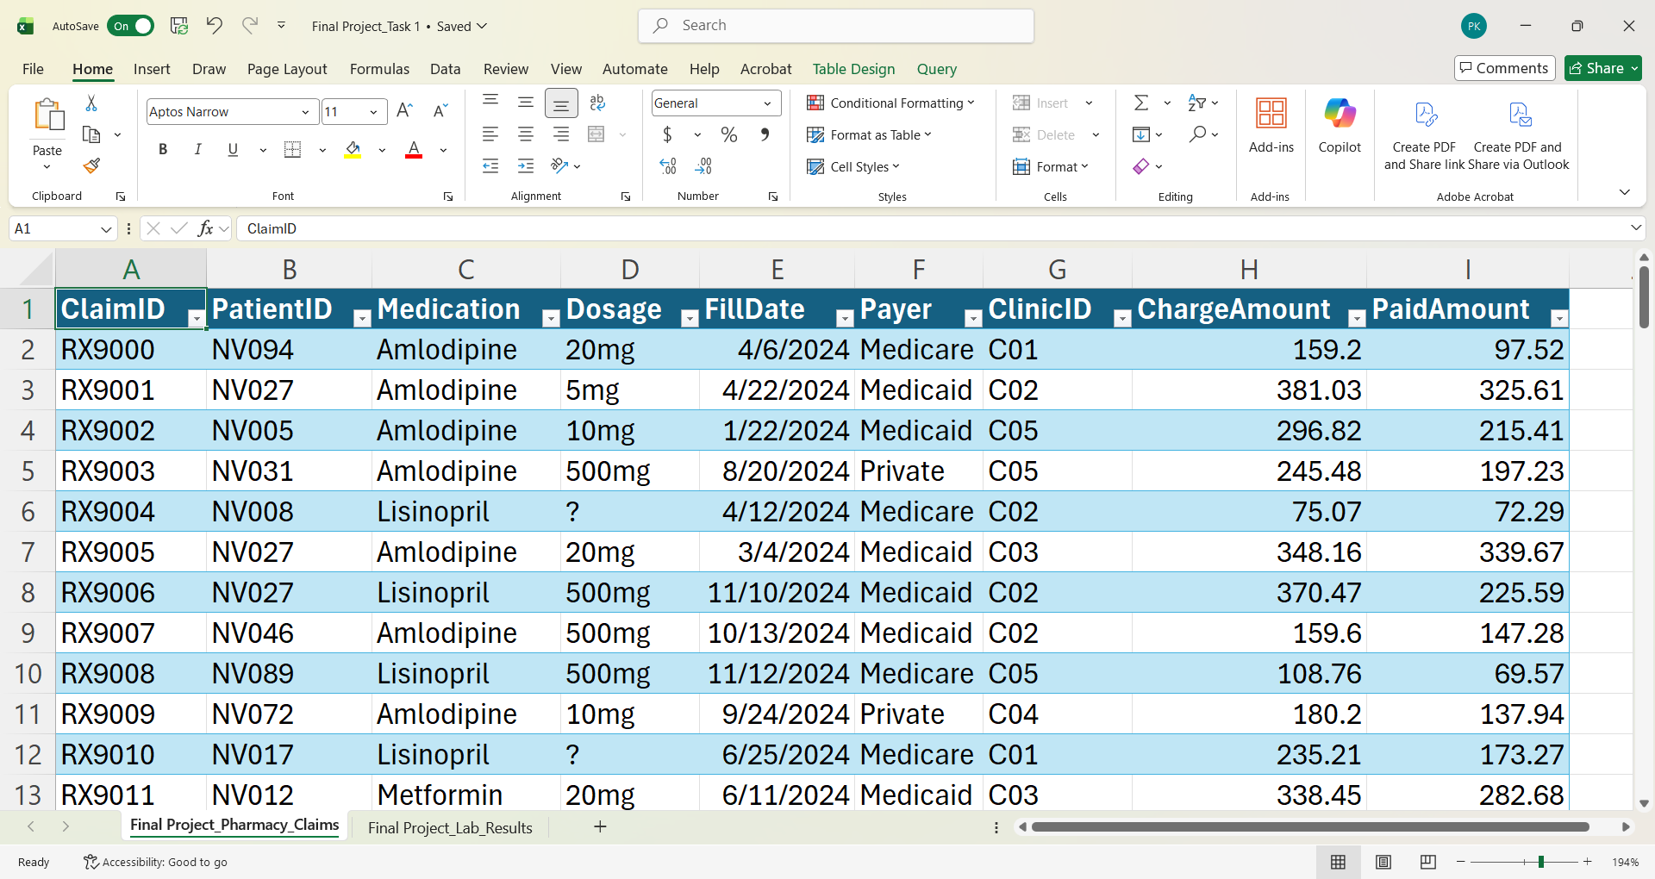
1b | Screenshot of Lab_Results.xlsx | 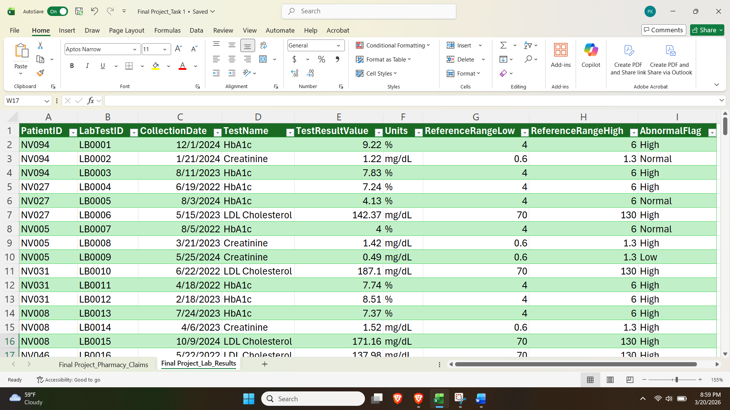

Task 2: Analyze the data sets using Excel
2.1a | Considering the Pharmacy_Claims data set, how many paid amounts exceed $250? | 21
2.1b | Considering the Pharmacy_Claims data set, which payer has paid the highest amount? | Medicaid
2.1c | Considering the Pharmacy_Claims data set, what is the total amount paid by the payer identified in part 2.1b. | $18,396.07
2.2a | Based on the Lab_Results data set, what is the top result within the LDL Cholesterol test. | 187.1 mg/dL
2.2b | Based on the Lab_Results data set, what is the average value for the LDL Cholesterol test? | 134.6391 mg/dL
2,2c | Based on the Lab_Results data set, how many patients have high LDL Cholesterol (> 160 mg/dL)?? | 12

Task 3: Identify and fix the issues in a data set using Python
Activity number | Activity name | Screenshot
3.1a | Write the Python code to identify the number of missing values. | 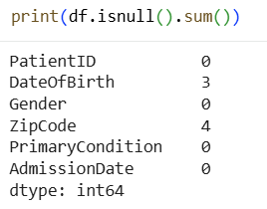
3.1b | Write the Python code to identify the number of duplicate values. | 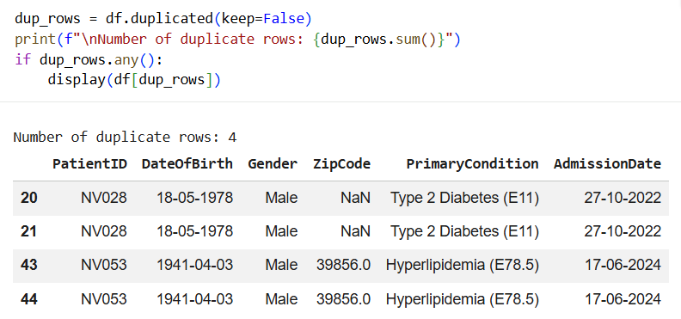
3.1c | Write the Python code to identify inconsistent categorical entries in the Gender column. | 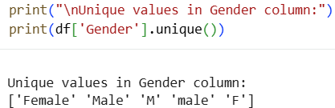
3.1d | Write the Python code to identify inconsistent date formats in the AdmissionDate column. | 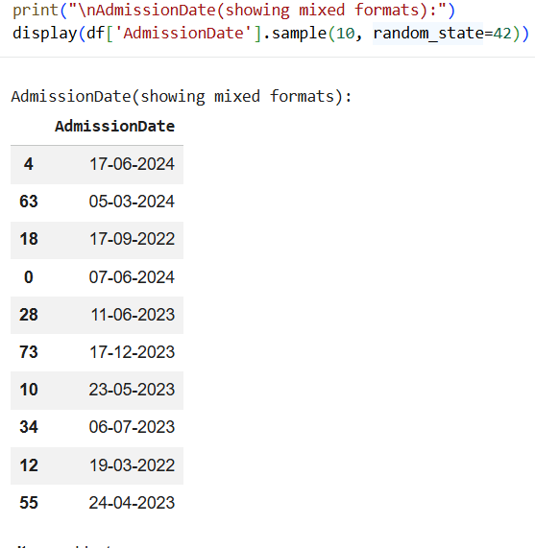
3.2a | Write the Python code to handle missing values appropriately. | 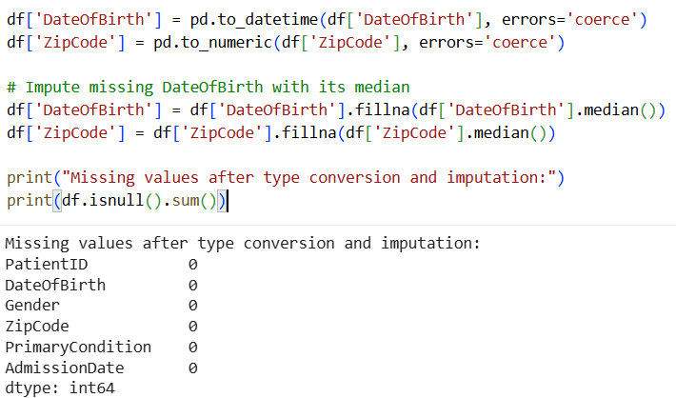
3.2b | Write the Python code to remove exact duplicate rows. | 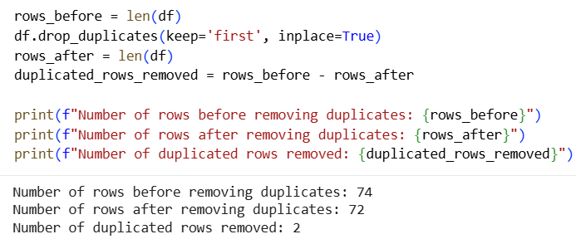
3.2c | Write the Python code to standardize gender values. | 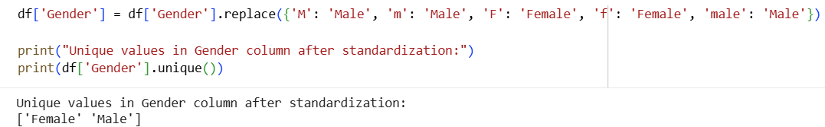
3.2d | Write the Python code to standardize date values. | 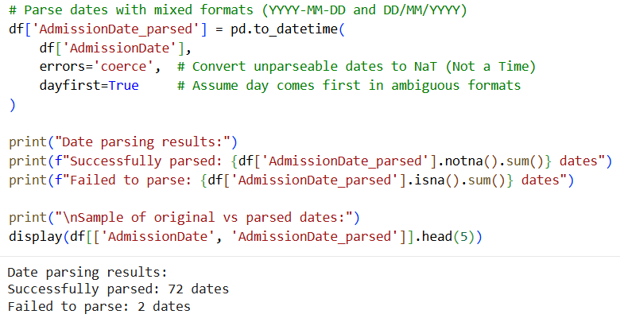  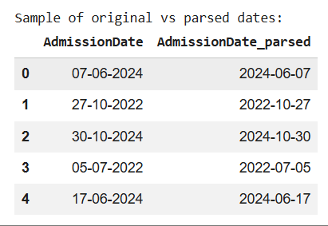

Task 4: Analyze the data sets using SQL
Activity number | Activity | Screenshot of Code and Output
4a | Write an SQL query to list all patients born before 1980. | 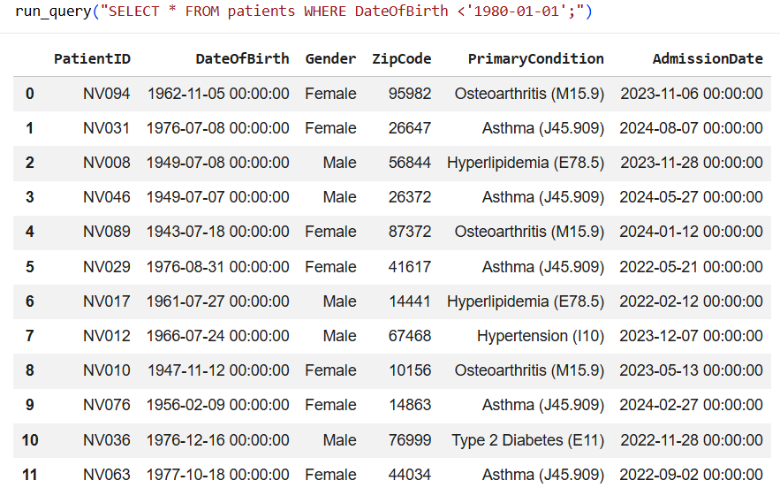
4b | Write an SQL query to list all female patients with Type 2 Diabetes. | 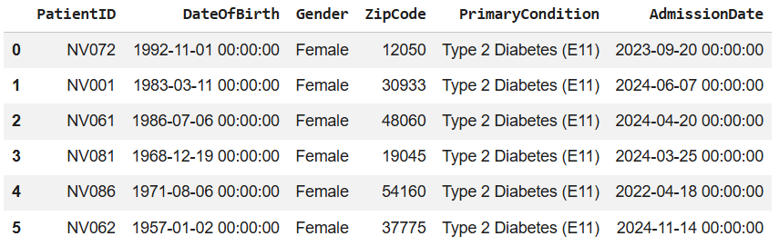
4c | Write an SQL query to display all lab tests performed. List each patient (PatientID, Gender, and DateOfBirth from patients) with their lab test name and result value (TestName and TestResultValue from lab_results). | 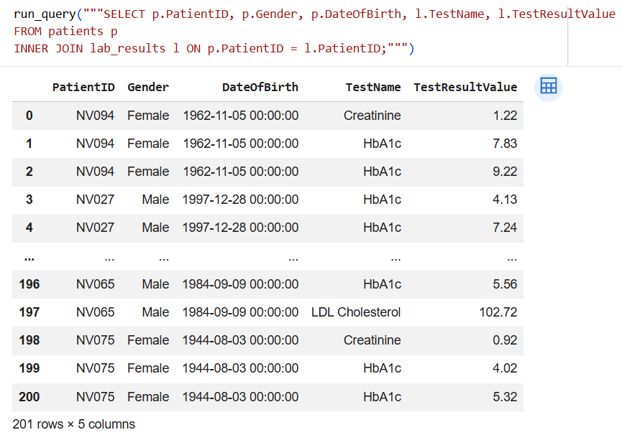
4d | Write the SQL query to display all distinct patients with their payer(s). List each patient (PatientID, Gender, DateofBirth from patients) with their payer(s) from the pharmacy_claims data set. | 